Software Requirements Specification
BLOOD DONATION MANAGEMENT SYSTEM

Prepared by
Durgesh Prajapati -43
Gulab Singh -26
Sujit Pandit -42
Ankita Yadav-61
Shree L.R. Tiwari College of Engineering
17th May 2021
Table of Contents
Table of Contents ii
Revision History ii
1. Introduction 1
1.1 Purpose 1
1.2 Document Conventions 1
1.3 Intended Audience and Reading Suggestions 1
1.4 Product Scope 1
1.5 References 2
2. Overall Description 2
2.1 Product Perspective 2
2.2 Product Functions 2
2.3 User Classes and Characteristics 3
2.4 Operating Environment 3
2.5 Design and Implementation Constraints 3
2.6 Assumptions and Dependencies 3
3. External Interface Requirements 4
3.1 User Interfaces 4
3.2 Login Interface 4
3.3 Search 4
3.4 Admin's Control Panel 5
4. System Features 5
4.1 System Feature 1 5
5. Other Nonfunctional Requirements 6
5.1 Performance Requirements 6
5.2 Safety Requirements 6
5.3 Security Requirements 6
5.4 Software Quality Attributes 6
6. Other Requirements 7
Appendix A: Analysis Models 7
1 Use Case Diagram 7
2 Class Diagram 8
3 State Diagram 9
4 Component Diagram 10
5 Sequence Diagram 11
6 Deployment Diagram 12

Introduction

Purpose
Blood donation is required during an organ transplant, accidents, cancer treatment etc. For blood donation, one needs to check for a donation camp or needs to visit blood bank.
The Manual Blood donation system has many disadvantages which includes, it is too time consuming, often leads to error prone results, consumes lot of manpower, lacks donor information, retrieval of data takes a lot of time, percentage of accuracy is less. In the time of emergency, it becomes difficult to approach the right donor. Rare blood groups are not available all the time at all blood banks and recipients find difficulties to track the right blood donor.
So it will be very helpful if we can donate as well as get blood online .

Document Conventions
- Entire document should be justified.
- Convention for Main title
- Font face: Times New Roman
- Font style: Bold
- Font Size: 14
- Convention for Sub title
- Font face: Times New Roman
- Font style: Bold
- Font Size: 12
- Convention for body
- Font face: Times New Roman
- Font Size: 12

Intended Audience and Reading Suggestions
The intended readers of this document are the developers of the site, doctors and patient.
This document is easy and compatible to read for all different types of users.

Product Scope

Blood donation is required during an organ transplant, accidents, cancer treatment etc. For blood donation, one needs to check for a donation camp or needs to visit blood banThe Manual Blood donation system has many disadvantages which includes, it is too time consuming, often leads to error prone results, consumes lot of manpower, lacks donor information, retrieval of data takes a lot of time, percentage of accuracy is less. In the time of emergency, it becomes difficult to approach the right donor. Rare blood groups are not available all the time at all blood banks and recipients find difficulties to track the right blood donor.So it will be very helpful if we can donate as well as get blood online .

References
- IEEE Papers
- Security Vulnerabilities in JavaScript Hotpatching in iOS with a CommerFLDl and Open-Source Tool.
- Adding Security to the JavaScript-based Agent Middleware SiebogJS.
- Webpage Encryption Based on Polymorphic JavaScript Algorithm.

Overall Description

Product Perspective

This online blood donation management system maintains the list of blood donors and also helps the recipients to track and search the right donor easily. It has two modules namely Admin and User. Admins can add hospitals having blood banks and can also add various blood donation camps. He/she can also view the list of donors of a particular area with proper Blood cross match. He/she can also check for blood requests and in case of emergency he/she can send notifications to blood donors as per the requirements. Users can register and make a request. Users can also register as a donor. Donors can check for Blood camps and hospitals for blood donation and will be getting notifications in case of emergency.

Product Functions
There are several major functions that our project will perform. The most important is the ability to share their visited campground experience in the comments section. Brief functions of our project are –
- Login / Signup
- Blood Test
- Create Branch
- Emergency
- BloodRequest
- TrackDonation
- StorageBlood

User Classes and Characteristics
- Donar

- Person

- Equipment

- Laborant

- BloodAnalysis

- BloodDistribution

- Blood

- PateintApproval

- Doctor

- Branches

- Admin

Operating Environment
The product will be operating in windows environment. The blood donation management system is a website and shall operate in all famous browsers, for a model we are taking Microsoft Internet Explorer, Google Chrome, and Mozilla Firefox. Also, it will be compatible with the IE 6.0. Most of the features will be compatible with the Mozilla Firefox & Opera 7.0 or higher version. The only requirement to use this online product would be the internet connection. The hardware configuration includes Hard Disk: 40 GB, Monitor: 15” Color monitor, Keyboard: 122 keys. The basic input devices required are keyboard, mouse and output devices are monitor, printer etc.

Design and Implementation Constraints
Security was the main constraints in our designing of the website, as security is main aspect of every website to keep user’s data confidential to others. The wesite requires a connection for full functionality application of the website. If the connection is lost during an active section the result will not be displayed and website will not function. Full functionality of the application will be resume upon reconnection.

Assumptions and Dependencies
The assumptions are:
- The coding should be error free.
- The system should be user-friendly so that it is easy to use for the users.
- The information of all users, activities and result must be stored in a database that is accessible by the website
- The system should have more storage capacity and provide fast access to the database
- The system should function every time.
- This website is running 24 hours a day.
- Users may access from any computer that has Internet browsing capabilities and a Department of Information Technology.
- Users must have their correct usernames and passwords to enter into their online accounts and do actions.
The dependencies are:
- The specific hardware and software due to which the product will be run.
- On the basis of listing requirements and specification the project will be developed and run.
- The end users (admin) should have proper understanding of the product.
- The system should have the general report stored.
- The information of all the users must be stored in a database that is accessible by the Admin and the data entered should be correct.

External Interface Requirements

User Interfaces
The software provides good graphical interface for the user and the administrator can operate on the system, performing the required task such as create, update, viewing the details of the people.
- It allows user to view quick overview related to different campgrounds.
- It provides buttons to click and view/edit the campgrounds.
- The user interface must be customizable by the administrator.
- All the modules provided with the software must fit into this graphical user interface and accomplish to the standard defined
- The design should be simple and all the different interfaces should follow a standard template.
- The user interface should be able to interact with the user management module and a part of the interface must be dedicated to the login/logout module.

Login Interface
In case the user is not yet registered, he can enter the details and register to create his account. Once his account is created, he can ‘Login’ which asks the user to type his username and password. If the user entered either his username or password incorrectly then an error message appears.

Search
The member can search for different campgrounds as per their wish and the system will display the campgrounds related to the keywords entered.

3.4 Users Control Panel
This control panel will allow users to add/remove campgrounds; add, edit, or remove a comment.
The users of the system should be provided the surety that their account is secure. This is possible by providing User authentication and validation of members using their unique member ID, Proper monitoring by the administrator which includes updating account status, showing a popup if the member enters invalid input, giving proper output/result as per entered valid input data, giving campgrounds list to the users as per their result, Proper accountability which includes not allowing a member to see other member’s account. Only administrator will see and manage all member accounts.

4.1 System Feature 1

4.1.1 Functional Requirements
- Administrator:

- Database Management: Control the database and keep track of all records of user details.

- View all details: View the details of all employees and control the whole site.

- Advertising the Site: Responsible for making advertisements for the site.

- Users:

- Login: Users must have a valid login id to enter into the site.

- Registration: New users can sign up by creating new ID.

- Logout: User must logout of the site after checking the required parameter.

- Visitors:

- Visiting the Site: Can only visit the site without registration.

Other Nonfunctional Requirements

Performance Requirements
The proposed system that we are going to develop will be hosted on a web server and all the people who wants to access the website can use and calculate their health parameters. Therefore, it is expected that the database would perform functionally all the requirements that are specified by the university. The performance of the system should be fast and accurate ¬ our website shall handle expected and non-expected errors in ways that prevent loss in information and long downtime period. Thus, it should have inbuilt error testing to identify invalid username/password. The system should be able to handle large amount of data. Thus it should accommodate high number of donar without any fault.

Safety Requirements
The database may get crashed at any certain time due to virus or operating system failure. Therefore, it is required to take the database backup so that the database is not lost. Proper UPS/inverter facility should be there in case of power supply failure.

Security Requirements
- System will use secured database.
- Normal users can just read information but they cannot edit or modify anything except their personal and some other information.
- Proper user authentication should be provided.
- No one should be able to hack user’s password.
- There should be separate accounts for admin and members such that no member can access the database and only admin has the rights to update the database.

Software Quality Attributes
- There may be multiple admins creating the project, all of them will have the right to create changes to the system. But the members or other users cannot do changes.
- The project should be open source.
- The user be able to easily find and explore the website.

Other Requirements
The purpose of this SRS is to specify the requirements of the web-based software application, which is an online healthcare system. This Software Requirements Specification provides a complete description of all the functions and specifications of modules. This document contains the software requirements of Online Healthcare. Hence no other requirements needed.
Appendix A: Analysis Models
Analysis model operates as a link between the 'system description' and the 'design model’. In the analysis model, information, functions and the behavior of the system is defined and these are translated into the architecture, interface and component level design in the 'design modeling'.

Use Case Diagram

Use case diagram is a diagram that shows a set of use cases and actors and their relationships. These diagrams are central to modeling the behavior of a system, a subsystem or a class. We use them to model the use case view of system. Use case diagram make systems, subsystems and classes approachable and understandable by presenting an outside view of how those elements may be used in the context. A use case diagram is a dynamic or behavior diagram in UML. Use case diagrams model the functionality of a system using actors and use cases.
Use cases are a set of actions, services, and functions that the system needs to perform. In this context, a "system" is something being developed or operated, such as a web site. The "actors" are people or entities operating under defined roles within the system. Use case diagrams are valuable for visualizing the functional requirements of a system that will translate into design choices and development priorities.

Use Case Diagram:
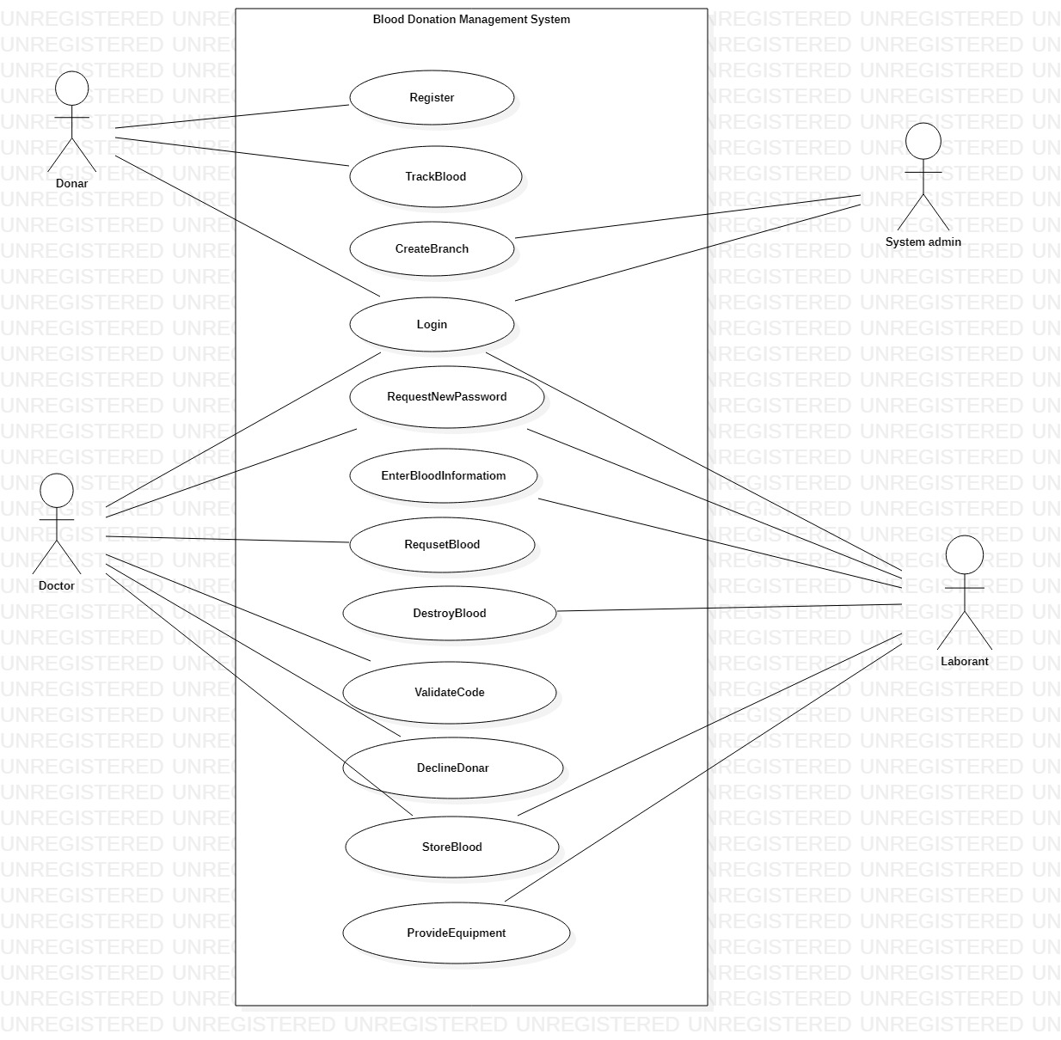

Class Diagram

Class diagrams are the main building blocks of every object-oriented methods. The class diagram can be used to show the classes, relationships, interface, association, and collaboration. UML is standardized in class diagrams. Since classes are the building block of an application that is based on OOPs, so as the class diagram has appropriate structure to represent the classes, inheritance, relationships, and everything that OOPs have in its context. It describes various kinds of objects and the static relationship in between them.
A description of a group of objects all with similar roles in the system, which consists of:
  - Structural features (attributes) define what objects of the class "know"
- Represent the state of an object of the class.
- Are descriptions of the structural or static features of a class.
  - Behavioural features (operations) define what objects of the class "can do"
- Define the way in which objects may interact.
- Operations are descriptions of behavioral or dynamic features of a class.

Class Diagram
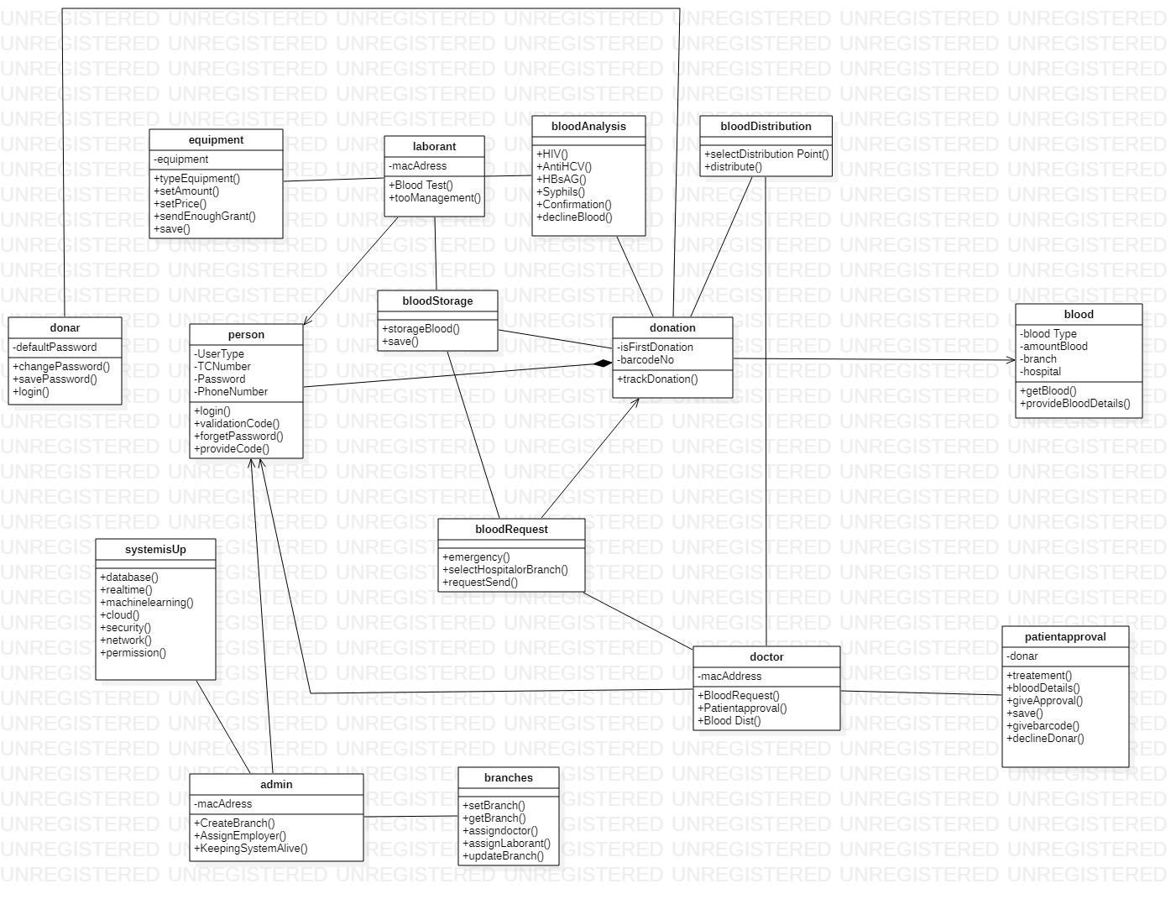

3. Activity Diagram
Activity diagram is another important diagram in UML to describe the dynamic aspects of the system. Activity diagram is basically a flowchart to represent the flow from one activity to another activity. The activity can be described as an operation of the system.
The control flow is drawn from one operation to another. This flow can be sequential, branched, or concurrent. Activity diagrams deal with all type of flow control by using different elements such as fork, join, etc
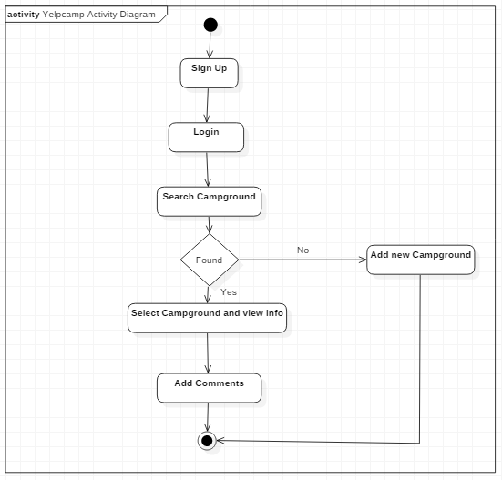

4.State Diagram
UML State Diagrams are interaction diagrams that detail how operations are carried out. They capture the interaction between objects in the context of collaboration. Sequence Diagrams are time focus and they show the order of the interaction visually by using the vertical axis of the diagram to represent time what messages are sent and when.
Sequence diagrams are a popular dynamic modeling solution in UML because they specifically focus on lifelines, or the processes and objects that live simultaneously, and the messages exchanged between them to perform a function before the lifeline ends.

State Diagram:

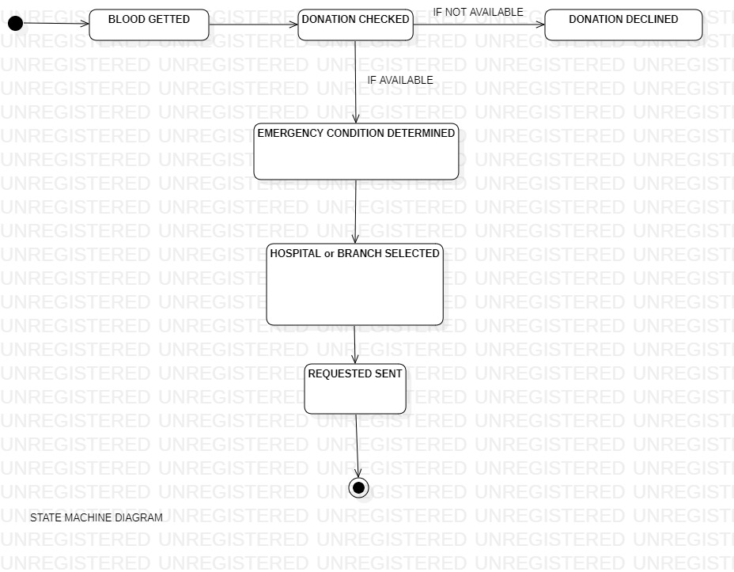

5.Component Diagram

UML Component diagrams are used in modeling the physical aspects of object-oriented systems that are used for visualizing, specifying, and documenting component-based systems and also for constructing executable systems through forward and reverse engineering. Component diagrams are essentially class diagrams that focus on a system's components that often used to model the static implementation view of a system.
A component diagram breaks down the actual system under development into various high levels of functionality. Each component is responsible for one clear aim within the entire system and only interacts with other essential elements on a need-to-know basis.

Component Diagram:

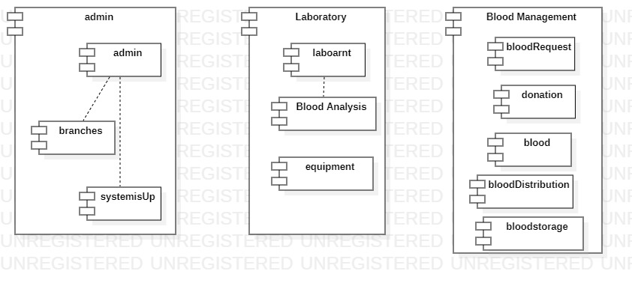

6. Sequence Diagram

A sequence diagram simply depicts interaction between objects in a sequential order i.e. the order in which these interactions take place. We can also use the terms event diagrams or event scenarios to refer to a sequence diagram. Sequence diagrams describe how and in what order the objects in a system function. These diagrams are widely used by businessmen and software developers to document and understand requirements for new and existing systems.

Sequence Diagram:
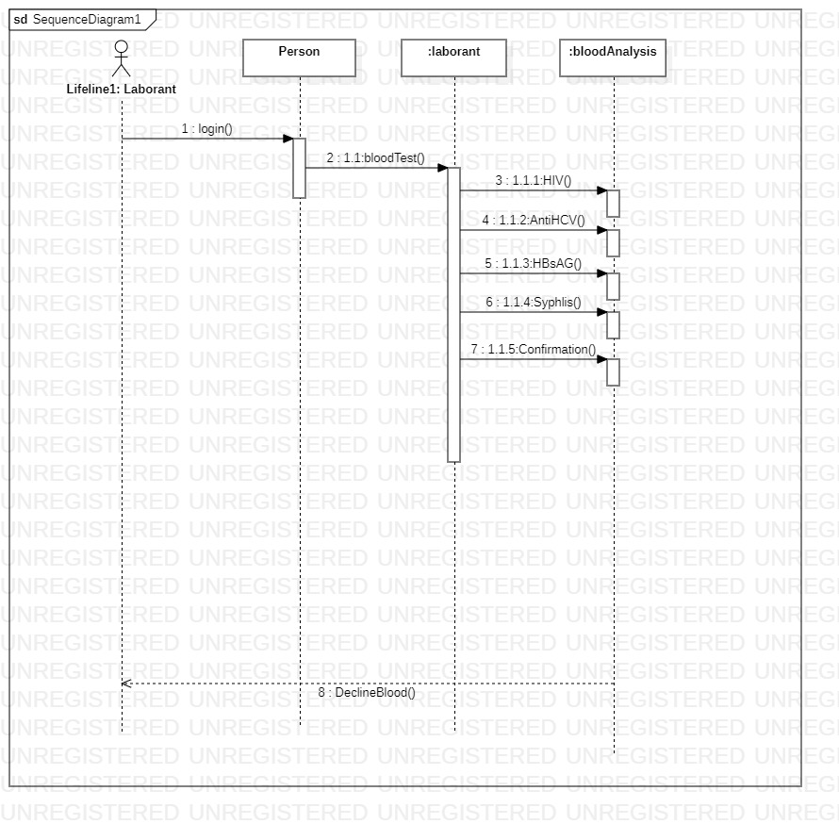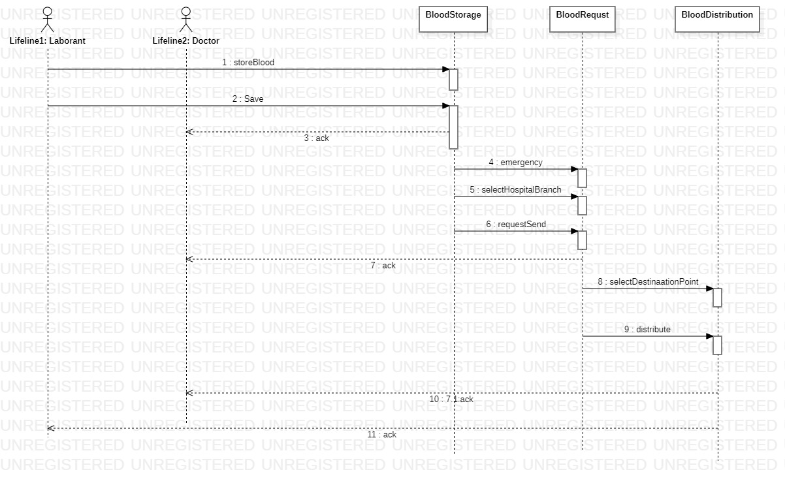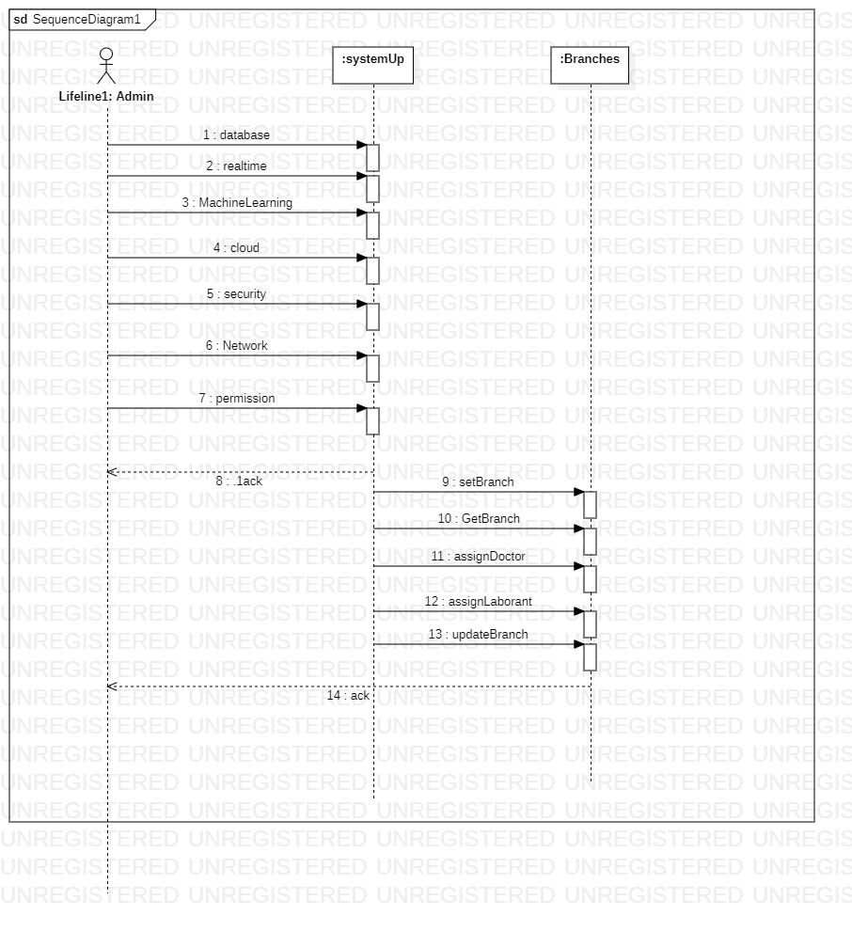

7. Deployment Diagram

A UML deployment diagram is a diagram that shows the configuration of run time processing nodes and the components that live on them. Deployment diagrams is a kind of structure diagram used in modeling the physical aspects of an object-oriented system. They are often being used to model the static deployment view of a system.
Deployment diagrams are made up of several UML shapes. The three-dimensional boxes, known as nodes, represent the basic software or hardware elements, or nodes, in the system. Lines from node to node indicate relationships, and the smaller shapes contained within the boxes represent the software artifacts that are deployed.

Deployment Diagram:

